November / December 2015 Newsletter Volume 2 Issue 2
Elizabeth Stewart PTA
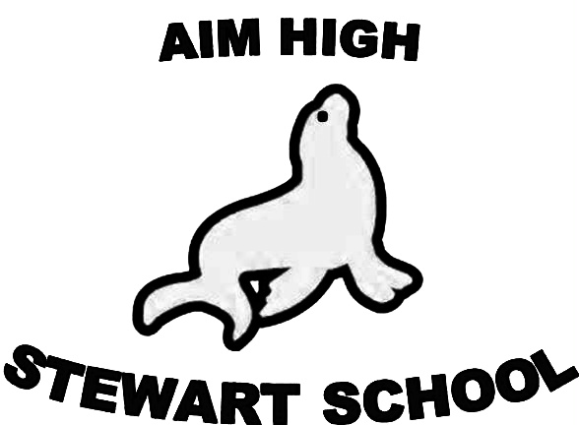

2015-2016 Executive Board

President: Susyn Normington
(president@stewartpta.com)

Vice-President: Trinh Joyner

Treasurer: Shila Ramrakha
(treasurer@stewartpta.com)

Secretary: Barbara Melton

Auditor: Open Position

Parliamentarian: Open Position

Fundraising Chair: Open Position (fundraising@stewartpta.com)

Membership Chair: Laurie Melton
(volunteer@stewartpta.com)

Website Chair: Brian Normington
(webmaster@stewartpta.com)

ETree Chair: Kimberly Baker-Hunter
(stewart.school.etree@gmail.com)

Communications Chair: Open

Stewart Shout Out
www.stewartpta.com

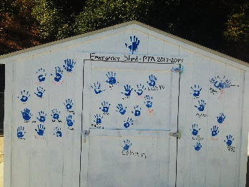
* Back to School BBQ - Over 100 parents, students and teachers had fun at our first PTA event of the year! We enjoyed seeing the creative projects that our students and teachers made and we also decorated the Emergency Shed with hand prints. And we raised over $400!

* Box Tops - Congratulations to Ms. Hoopaugh’s 4th Grade class for collecting the most Box Tops! We hope you enjoy your ice cream party! Thank you to everyone for participating and collectively raising over $300 for Stewart. Continue to turn in your Box Tops all year! We can submit another set on March 1, 2016.
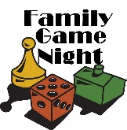* Family Game Night - November 13th @ 6pm is our first Family Game Night! Join us for classic family board games for kids and adults of all ages. Or try your luck at our poker table! Pizza slices, candy and drinks will be available for $1 each. Leave the electronics at home and have a new kind of family fun!

Words of Character
Congratulations to all our October students!
The word of the month for November is Tolerance/Compassion.
The word of the month for December is Honesty.

* Mixed Bag Fundraiser - Thank you to everyone who participated in the Mixed Bag Fundraiser! We exceeded our fundraising goals!! The money we raised will go to school assemblies, teacher stipends and supplies for the office. Thank you!! Orders and prizes should be delivered in November. Look for an ETree with the exact date.

* Family Movie Night - Kids and adults enjoyed fresh popcorn and family fun at our first Movie Night of the year! Mark your calendar for our next one January 29th!

Mark Your Calendar!
Event | Description | Date
Family Game Night | Join us for classic family board games for kids and adults of all ages. | Friday  November 13th @ 6pm
Mixed Bag Order Delivery | Date is still TBD, but look for the update on ETree and Facebook | In November - TBD
PTA Meeting | Come join us to hear about PTA plans for the year and how you can help! | Tuesday  January 12th @ 6pm
Family Movie Night | Enjoy a FREE movie! Purchase pizza slices, popcorn, candy and drinks for only $1 each. | Friday  January 29th @ 6pm
Box Tops | Continue to turn in your Box Tops all year | Next submission:  March 1, 2016

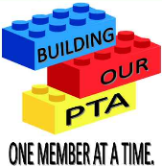
PTA Memberships and Donations - It's never too late to join the PTA. For only $10 a year your money supports Stewart events and children advocacy at the state and national PTA.
Check out www.capta.org (State Level) or www.32ndpta.org (West Contra Costa).

Next PTA meeting – Tuesday, January 12th at 6:00 pm
We will not have a meeting in November or December.

Have Ideas or just want to be a part of the Fundraising Committee? Would you like to volunteer at one of our events? Please contact Susyn at president@stewartpta.com if interested.

